BEATING THE DROUGHT
REQUIRES DROUGHT TOLERANT TURFGRASS.
IT REQUIRES



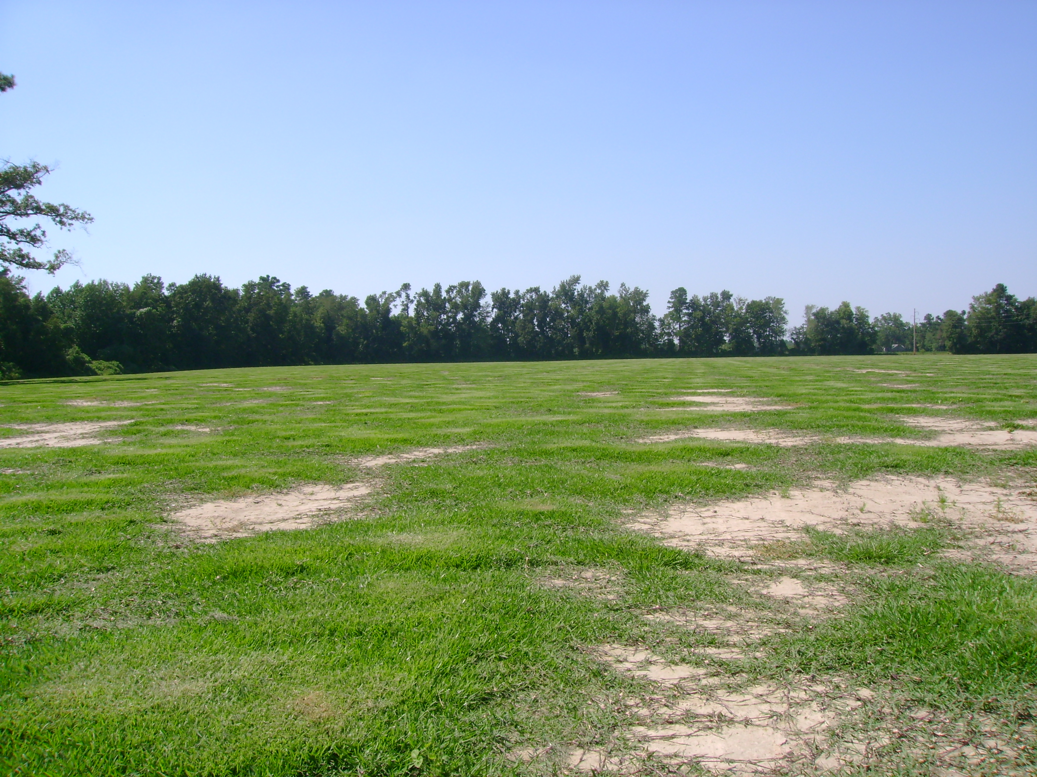
JaMur Zoysia Grow-In After Four Months On Un-Irrigated Land

With the drought that continues to reek environmental havoc across most of the Southeastern United States, water usage, conservation and availability remains a top priority and concern for the entire agricultural community and general public alike.

The discussion of drought tolerance and drought avoidance capabilities of various turfgrass cultivars continues to be debated. Turf breeders, producers and even University Extension Specialists can’t even come to an accord on what varieties can best meet our current environmental challenges. In addition, how do we deal with government imposed watering restrictions and in many cases, total outdoor watering bans?

The JaMur Zoysiagrass production field pictured above was planted in May of 2008 in Council, North Carolina. This photograph was taken the first week of September 2008. Conservatively speaking, this field is approximately 70% covered and there has never been so much as an inch of irrigation or supplemental water applied to this field, as it is all un-irrigated land. Bottom line, if it doesn’t rain, it doesn’t get water!

This is not to suggest that JaMur Zoysia doesn’t need water. It does however; once again validate the point that JaMur’s irrigation requirements are far less than those required by most all other commercially produced warm-season turfgrass varieties and every fescue selection and/or blend.

This is due to the prolific root, rhizome and stolon production of this amazing zoysiagrass variety. So, not only will JaMur beat the drought while requiring less water and fertilizer, it will recover quickly from damage. In addition, JaMur will produce nearly twice the sod harvests for the sod farmer in the same amount of time it takes to grow-in a single crop of the other zoysia varieties.

